Database Management System Homework 1 ----- NotAP

Group member: Qiang Xiao

Yingxuan Li

Xianzhao Liao

**outline**

To make the management easier, we design a database named NotAP, which can be used for the company. This database aims to carry out efficient information management. Based on this goal, we create 19 tables to store the information. In order to avoid anomalies and simplify the organization, all of the tables are in 3NF.

The design of these tables is based on the relationship among entities. There are mainly five entities: personnel, facilities, projects, financial and organization structure. After analyzing the attributes and relationship of these entities, we design the database as following figure. To test the function of the database, we add some tuples to each table.

**ER Diagram**

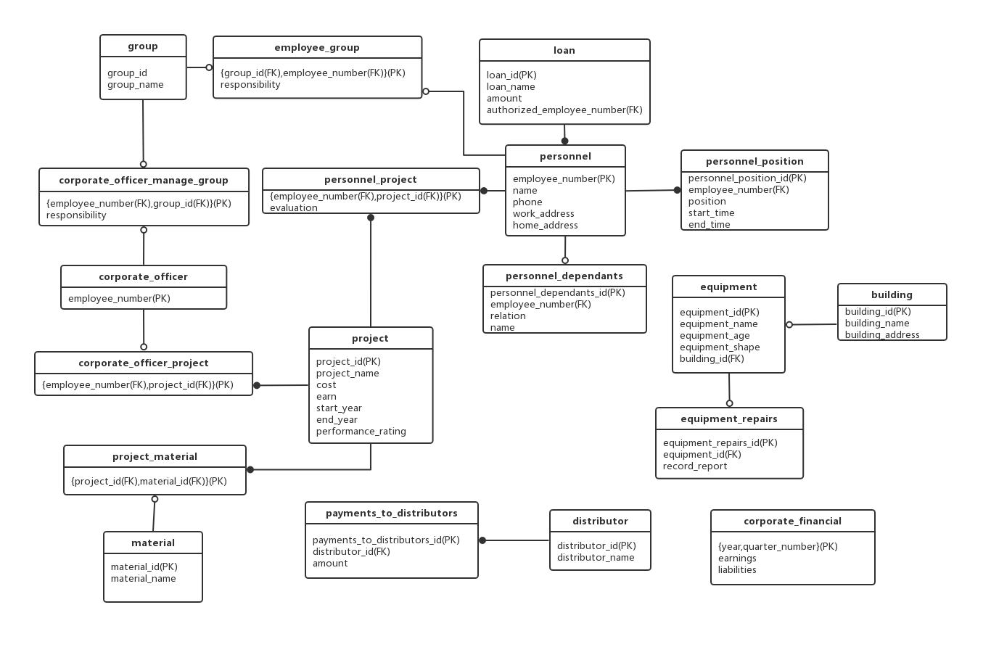

**Tables and explanations**

**Create schema:**

DROP DATABASE IF EXISTS NotAP;

CREATE DATABASE NotAP;

USE NotAP;

**(1)personnel table**

|  |
| --- |
|  |

CREATE TABLE `personnel` (

`employee_number` int(11) NOT NULL,

`name` varchar(45) NOT NULL,

`phone` varchar(20) NOT NULL,

`work_address` varchar(45) DEFAULT 'null',

`home_address` varchar(45) DEFAULT 'null',

PRIMARY KEY (`employee_number`)

)

**(2)personnel_position table**

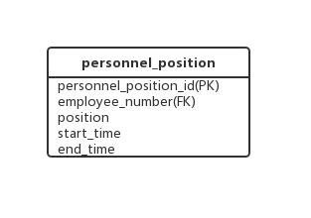 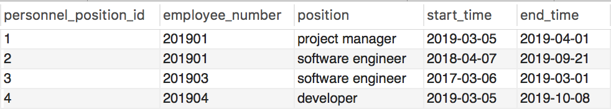

CREATE TABLE `personnel_position` (

`personnel_position_id` int(11) NOT NULL AUTO_INCREMENT,

`employee_number` int(11) NOT NULL,

`position` varchar(45) NOT NULL,

`start_time` date DEFAULT NULL,

`end_time` date DEFAULT NULL,

PRIMARY KEY (`personnel_position_id`),

KEY `personnel_position_ibfk_1_idx` (`employee_number`),

CONSTRAINT `personnel_position_ibfk_1` FOREIGN KEY (`employee_number`) REFERENCES `personnel` (`employee_number`) ON DELETE CASCADE ON UPDATE RESTRICT)

**(3)personnel_dependants table**

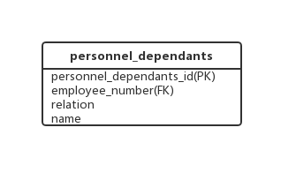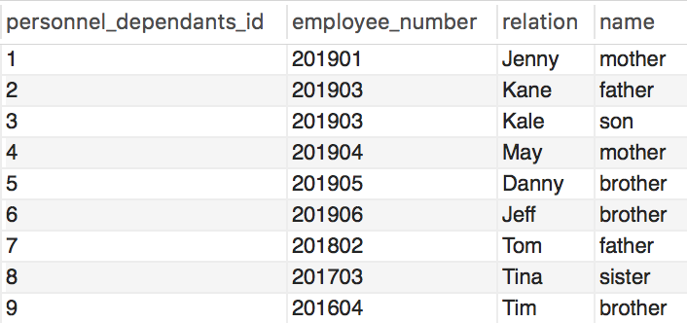

CREATE TABLE `personnel_dependants` (

`personnel_dependants_id` int(11) NOT NULL AUTO_INCREMENT,

`employee_number` int(11) NOT NULL,

`relation` varchar(45) NOT NULL,

`name` varchar(45) NOT NULL,

PRIMARY KEY (`personnel_dependants_id`),

KEY `personnel_dependants_ibfk_1_idx` (`employee_number`),

CONSTRAINT `personnel_dependants_ibfk_1` FOREIGN KEY (`employee_number`) REFERENCES `personnel` (`employee_number`) ON DELETE CASCADE ON UPDATE RESTRICT

)

**(4)equipment table**

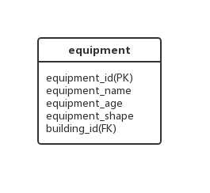 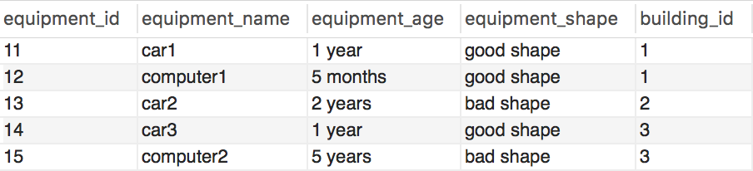

CREATE TABLE `equipment` (

`equipment_id` int(11) NOT NULL,

`equipment_name` varchar(45) NOT NULL,

`equipment_age` varchar(45) NOT NULL,

`equipment_shape` varchar(45) NOT NULL,

`building_id` int(11) DEFAULT NULL,

PRIMARY KEY (`equipment_id`),

KEY `equipment_ibfk_1_idx` (`building_id`),

CONSTRAINT `equipment_ibfk_1` FOREIGN KEY (`building_id`) REFERENCES `building` (`building_id`) ON DELETE SET NULL

)

**Explanation：**

1 NF

all domains contains scalar values

2NF

Non-key attributes are fully dependent on equipment_id

3NF

Non-key attributes are non-transitively dependent on equipment_id

**(5)building table**

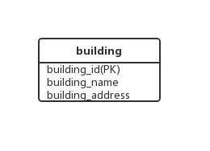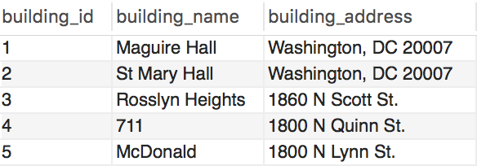

CREATE TABLE `building` (

`building_id` int(11) NOT NULL,

`building_name` varchar(45) NOT NULL,

`building_address` varchar(45) NOT NULL,

PRIMARY KEY (`building_id`)

)

**(6)equipment_repairs table**

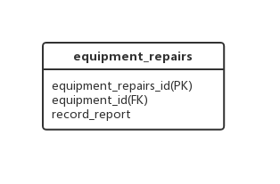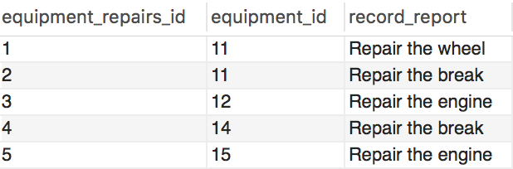

CREATE TABLE `equipment_repairs` (

`equipment_repairs_id` int(11) NOT NULL,

`equipment_id` int(11) NOT NULL,

`record_report` varchar(100) DEFAULT NULL,

PRIMARY KEY (`equipment_repairs_id`),

KEY `equipment_repairs_ibfk_1_idx` (`equipment_id`),

CONSTRAINT `equipment_repairs_ibfk_1` FOREIGN KEY (`equipment_id`) REFERENCES `equipment` (`equipment_id`) ON UPDATE RESTRICT ON DELETE NO ACTION)

**(7)project table**

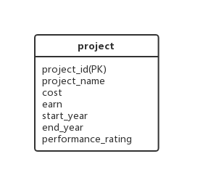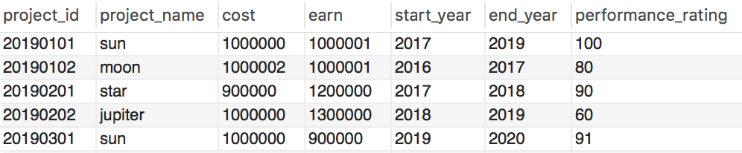

CREATE TABLE `project` (

`project_id` int(11) NOT NULL,

`project_name` varchar(45) NOT NULL,

`cost` int(20) DEFAULT NULL,

`earn` int(20) DEFAULT NULL,

`start_year` year(4) DEFAULT NULL,

`end_year` year(4) DEFAULT NULL,

`performance_rating` int(3) DEFAULT NULL,

PRIMARY KEY (`project_id`)

)

**Explanation：**

1 NF

all domains contains scalar values

2NF

Non-key attributes are fully dependent on equipment_id

3NF

Non-key attributes are non-transitively dependent on equipment_id

**(8)personnel_project table**

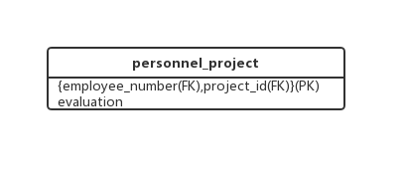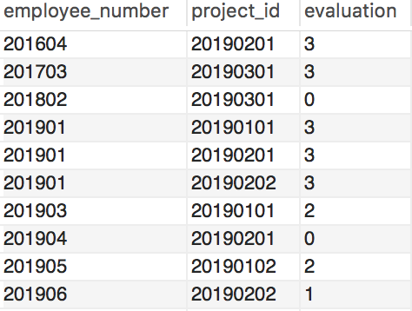

CREATE TABLE `personnel_project` (

`employee_number` int(11) NOT NULL,

`project_id` int(11) NOT NULL,

`evaluation` int(1) NOT NULL COMMENT '0:poor1:fair2:good3:great',

PRIMARY KEY (`employee_number`,`project_id`),

KEY `personnel_project_ibfk_2_idx` (`project_id`),

CONSTRAINT `personnel_project_ibfk_1` FOREIGN KEY (`employee_number`) REFERENCES `personnel` (`employee_number`) ON DELETE CASCADE ON UPDATE RESTRICT,

CONSTRAINT `personnel_project_ibfk_2` FOREIGN KEY (`project_id`) REFERENCES `project` (`project_id`) ON DELETE CASCADE ON UPDATE RESTRICT

)

**(9)material table**

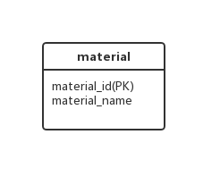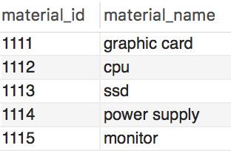

CREATE TABLE `material` (

`material_id` int(11) NOT NULL,

`material_name` varchar(45) NOT NULL,

PRIMARY KEY (`material_id`)

)

**(10)project_material table**

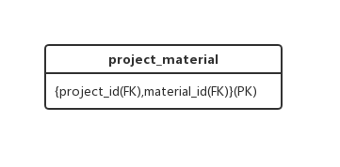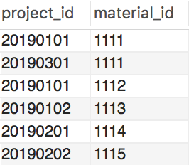

CREATE TABLE `project_material` (

`project_id` int(11) NOT NULL,

`material_id` int(11) NOT NULL,

PRIMARY KEY (`project_id`,`material_id`),

KEY `project_material_ibfk_2_idx` (`material_id`),

CONSTRAINT `project_material_ibfk_1` FOREIGN KEY (`project_id`) REFERENCES `project` (`project_id`) ON UPDATE RESTRICT,

CONSTRAINT `project_material_ibfk_2` FOREIGN KEY (`material_id`) REFERENCES `material` (`material_id`) ON UPDATE RESTRICT

)

**(11)corporate officer table**

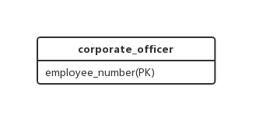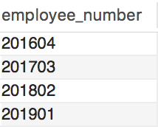

CREATE TABLE `corporate_officer` (

`employee_number` int(11) NOT NULL,

PRIMARY KEY (`employee_number`)

)

**(12)corporate_officer_project table**

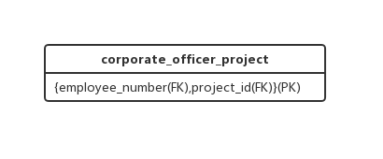

CREATE TABLE `corporate_officer_project` (

`employee_number` int(11) NOT NULL,

`project_id` int(11) NOT NULL,

PRIMARY KEY (`employee_number`,`project_id`),

KEY `corporate_officer_project_ibfk_1_idx` (`project_id`),

CONSTRAINT `corporate_officer_project_ibfk_1` FOREIGN KEY (`employee_number`) REFERENCES `corporate_officer` (`employee_number`) ON UPDATE RESTRICT,

CONSTRAINT `corporate_officer_project_ibfk_2` FOREIGN KEY (`project_id`) REFERENCES `project` (`project_id`) ON UPDATE RESTRICT

)

**(13)group table**

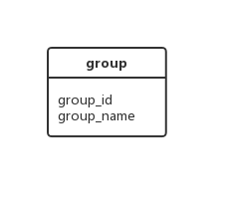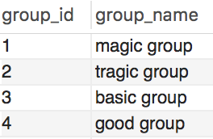

CREATE TABLE `group` (

`group_id` int(11) NOT NULL,

`group_name` varchar(45) NOT NULL,

PRIMARY KEY (`group_id`)

)

**(14)employee_group table**

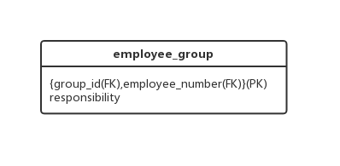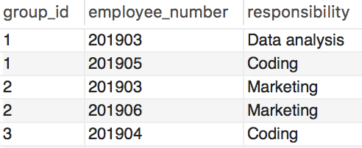

CREATE TABLE `employee_group` (

`group_id` int(11) NOT NULL,

`employee_number` int(11) NOT NULL,

`responsibility` varchar(45) DEFAULT NULL,

PRIMARY KEY (`group_id`,`employee_number`),

KEY `employee_group_ibfk_1_idx` (`employee_number`),

CONSTRAINT `employee_group_ibfk_1` FOREIGN KEY (`employee_number`) REFERENCES `personnel` (`employee_number`) ON DELETE CASCADE ON UPDATE RESTRICT,

CONSTRAINT `employee_group_ibfk_2` FOREIGN KEY (`group_id`) REFERENCES `group` (`group_id`) ON DELETE CASCADE ON UPDATE RESTRICT

)

**(15)corporate_officer_manage_group table**

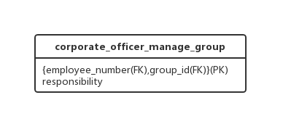 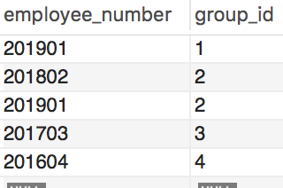

CREATE TABLE `corporate_officer_manage_group` (

`employee_number` int(11) NOT NULL,

`group_id` int(11) NOT NULL,

`responsibility` varchar(45) NOT NULL,

PRIMARY KEY (`employee_number`,`group_id`),

KEY `corporate_officer_manage_group_ibfk_2_idx` (`group_id`),

CONSTRAINT `corporate_officer_manage_group_ibfk_1` FOREIGN KEY (`employee_number`) REFERENCES `corporate_officer` (`employee_number`) ON DELETE CASCADE ON UPDATE RESTRICT,

CONSTRAINT `corporate_officer_manage_group_ibfk_2` FOREIGN KEY (`group_id`) REFERENCES `group` (`group_id`) ON DELETE CASCADE ON UPDATE RESTRICT

)

**(16)loan table**

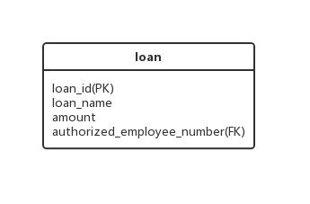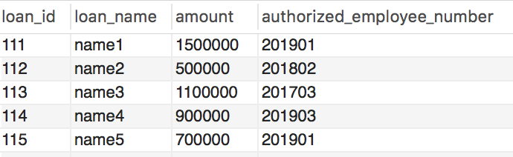

CREATE TABLE `loan` (

`loan_id` int(11) NOT NULL,

`loan_name` varchar(45) DEFAULT NULL,

`amount` int(20) DEFAULT NULL,

`authorized_employee_number` int(11) DEFAULT NULL,

PRIMARY KEY (`loan_id`),

KEY `loan_ibfk_1_idx` (`authorized_employee_number`),

CONSTRAINT `loan_ibfk_1` FOREIGN KEY (`authorized_employee_number`) REFERENCES `personnel` (`employee_number`)

)

**(17)corporate_financial**

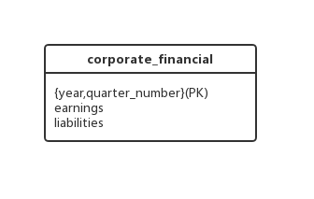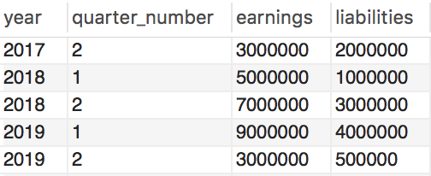

CREATE TABLE `corporate_financial` (

`year` year(4) NOT NULL,

`quarter_number` int(1) NOT NULL,

`earnings` int(11) NOT NULL,

`liabilities` int(11) NOT NULL,

PRIMARY KEY (`year`,`quarter_number`)

)

**(18)distributor table**

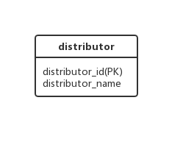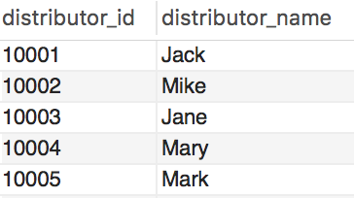

CREATE TABLE `distributor` (

`distributor_id` int(11) NOT NULL,

`distributor_name` varchar(45) NOT NULL,

PRIMARY KEY (`distributor_id`)

)

**(19)payments_to_distributors table**

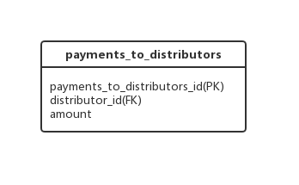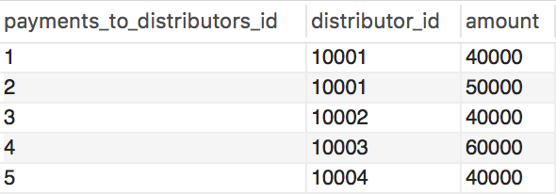

CREATE TABLE `payments_to_distributors` (

`payments_to_distributors_id` int(11) NOT NULL,

`distributor_id` int(11) NOT NULL,

`amount` int(20) NOT NULL,

PRIMARY KEY (`payments_to_distributors_id`),

KEY `payments_to_distributors_ibfk_1_idx` (`distributor_id`),

CONSTRAINT `payments_to_distributors_ibfk_1` FOREIGN KEY (`distributor_id`) REFERENCES `distributor` (`distributor_id`) ON DELETE RESTRICT ON UPDATE RESTRICT

)

**Queries**

* use NotAP;

SELECT DISTINCT a.employee_number, a.name

FROM personnel a, personnel_project b, project c

WHERE c.performance_rating >= 90

AND b.project_id = c.project_id

AND a.employee_number = b.employee_number;

**Explanation: We use distinct to avoid duplicates.**

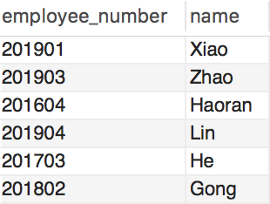

* use NotAP;

SELECT b.employee_number, b.name

FROM corporate_officer a, personnel b

WHERE b.home_address = 'Chevy Chase, Maryland'

AND a.employee_number = b.employee_number;

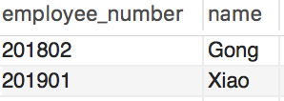

* use NotAP;

SELECT project.project_id, project.project_name

FROM project

WHERE project.earn - project.cost > 0;

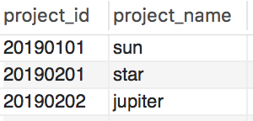

* use NotAP;

SELECT DISTINCT a.*

FROM personnel a, personnel_project b

WHERE b.evaluation = 0

AND a.employee_number=b.employee_number;

**Explanation: We use distinct to avoid duplicates.**

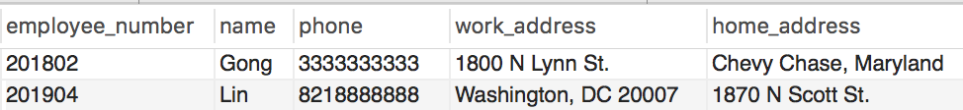

* use NotAP;

SELECT distributor.*

FROM distributor;

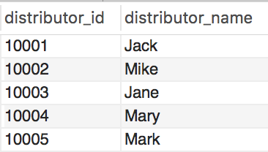

* use NotAP;

SELECT a.project_id, a.project_name

FROM project a, corporate_officer_project b

WHERE b.employee_number = '201901'

AND a.project_id = b.project_id;

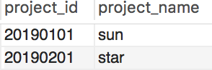

* use NotAP;

SELECT b.*, a.work_address

FROM personnel a, loan b

WHERE b.amount > 1000000

AND b.authorized_employee_number = a.employee_number;

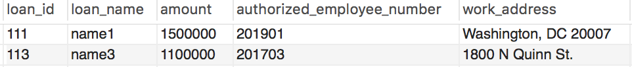

* use NotAP;

SELECT a.employee_number, a.name

FROM personnel a, personnel_project b, project c

WHERE c.start_year <= 2018

AND c.end_year >= 2018

AND c.project_id = b.project_id

AND b.employee_number = a.employee_number

GROUP BY b.employee_number

HAVING count(b.employee_number) > 2;

